Practical No 17

VIII. Resources required (Additional)
→ If any web resources required.

Resources used (Additional)
→ https://docs.microsoft.com/en-us/dotnet/visual-basic/language- reference/statements/function-statement
→ https://www.tutorialspoint.com/vb.net/vb.net_functions.htm

Program Code
  - Write a program using the concept of class & object in VB.Net.
- Module Module1
Sub Main()
Dim obj As New Test 'creating a object obj for Test Class obj.disp() 'Calling the disp method using obj Console.ReadLine()
End Sub End Module
Public Class Test Sub disp()
Console.WriteLine("Welcome to VB.NET") End Sub
End Class

Results (output of the program)
Welcome to VB.NET

Practical related Questions
  - Find output in following code.
➢ 4

Find Error in following code. Module Module1
Sub Main()
Dim b As B = New B(5) B = Display()

Dim c As C = New C(5) B = Display()
End Sub
- Compilation error (line 3, col 0): Type 'B' is not defined.
Compilation error (line 4, col 0): 'Display' is not declared. It may be inaccessible due to its protectio n level.
Compilation error (line 6, col 0): Type 'C' is not defined.
Compilation error (line 7, col 0): 'Display' is not declared. It may be inaccessible due to its protectio n level.

rcise
  - Write a program to identify Volume of Box Class, with three data members, length, breadth and height.
- Module Module1
Sub Main()
Dim obj As Box = New Box()
Dim vol As Integer
vol = obj.volume(2, 4, 4) Console.WriteLine("Length =" & obj.l) Console.WriteLine("Breadth =" & obj.b) Console.WriteLine("Height =" & obj.h) Console.WriteLine("Volume =" & vol) Console.ReadLine()
End Sub Class Box
Public l, b, h As Integer
Function volume(ByVal i As Integer, ByVal j As Integer,
_ByVal k As Integer)
Dim v As Integer l = i
b = j
h = k
v = l * b * h Return v
End Function End Class
End Module

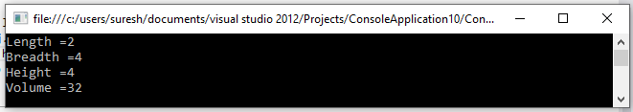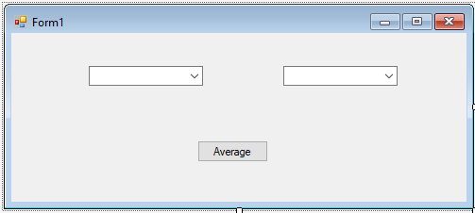
Output:
2. Implement a program to accept values from Combo Box and Display average of this in
message box using class.
➢

Public Class Form1

Private Sub Form1_Load(sender As Object, e As EventArgs) Handles MyBase.Load
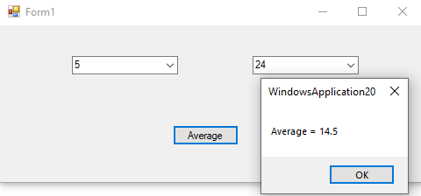ComboBox1.Items.Add(5) ComboBox1.Items.Add(8) ComboBox1.Items.Add(12) ComboBox1.Items.Add(20) ComboBox1.Items.Add(32)

ComboBox2.Items.Add(6) ComboBox2.Items.Add(11) ComboBox2.Items.Add(17) ComboBox2.Items.Add(24) ComboBox2.Items.Add(36)
End Sub

Private Sub Button1_Click(sender As Object, e As EventArgs) Handles Button1.Click
Dim average As Single
average = (Val(ComboBox1.Text) + Val(ComboBox2.Text)) / 2 MsgBox("Average = " & average)
End Sub End Class

OUTPUT:

